MoSCoW – Library Management System
Aim
To categorize requirements using the MoSCoW method.
Procedure
1. List all requirements.
2. Analyze impact & feasibility.
3. Categorize into:
- Must Have , Should Have
- Could Have
- Won’t Have
4. Enter into Excel/Google Sheet.
5. Add justification column
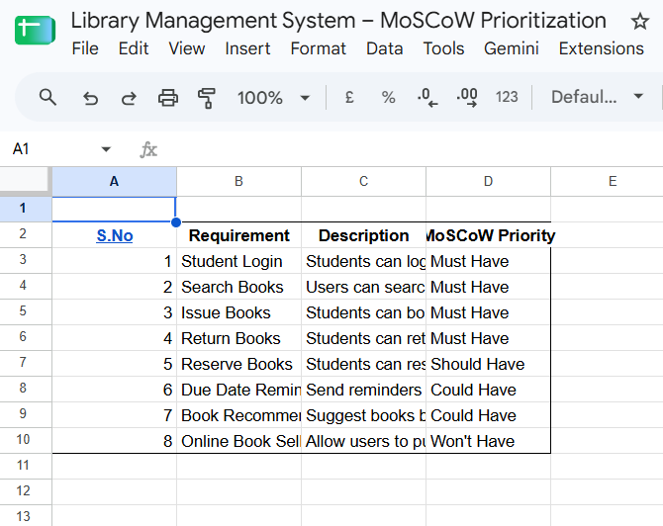

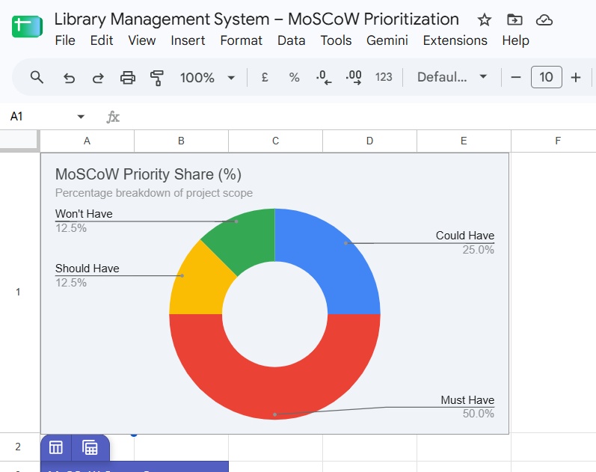

Result : Thus, The Requirements categorized successfully using MoSCoW prioritization

